

# Opel Mobile Touchflip 4G

## Type of device: Mobile

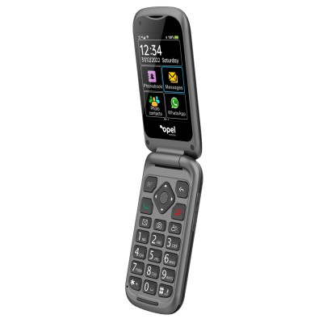

Actual Display Size : 2.8 inches

Button Type : Physical Keypad

Network Capability : 3G,4G

Year of Release : 2022

Average Price : $148 as of 23 11 2022

Other : 0

## Accessibility Features:

### Cognitive

* Photo Telephone List

Voice Notes

### Hearing Impairment and Deaf

* Bluetooth or Wi-Fi
* Hearing Aid Microphone Coupling
* Hearing Aid Telecoil Coupling

Text Messaging/SMS

### Vision

* Battery Alert - Audible
* Bluetooth or Wi-Fi
* Key Marker – Raised '5'
* Key Numbers - Standard Layout
* Key Press - Vibration or Click

Screen Magnifier

### Speech

* Bluetooth or Wi-Fi

Messaging Options - MMS

### Physical

* Bluetooth or Wi-Fi
* Physical Dialling Keys

Speaker-phone option

## How and where to get it from?

You can buy this phone from [Opel Mobile](https://www.opelmobile.com.au/product/touch-flip/), [Australia Post](https://auspost.com.au/shop/search?SearchTerm=opel+mobile+touchflip+4g), [Big W](https://www.bigw.com.au/search?text=opel+mobile+4g+touchflip), [Bing Lee](https://www.binglee.com.au/search?q=opel%20mobile%20touchflip%204g), [Officeworks](https://www.officeworks.com.au/shop/officeworks/search?istCompanyId=0403b0ba-0671-498f-aeb7-e2ff71b61924&istFeedId=00ff5695-1f12-4ff3-82f4-49dd39a43a69&istItemId=pqwwipppm&istBid=t&cm_mmc=Google:SEM:Always_on:RP|Catch-all|Untargeted|||||SH|Smart||&s_kwcid=AL!12073!3!632442522474!!!u!1673761049996!&gclid=Cj0KCQiAg_KbBhDLARIsANx7wAzNAF6bFfHzdF-u20rVpkhuE5LeggrlVzAzrCdxWhAwl4nY87-zhfMaAt9WEALw_wcB&gclsrc=aw.ds&q=opel%20mobile%20touchflip%204g&view=grid&page=1&sortBy=bestmatch), and other retailers.

## More information is available on:

[Opel Mobile TouchFlip 4G webpage](https://www.opelmobile.com.au/our-products/touch-flip/)

[Opel Mobile TouchFlip 4G PDF User Manual webpage](https://www.opelmobile.com.au/wp-content/uploads/2022/03/OM-TouchFlip-A4.pdf)